Idea Coach
Prompt 1:
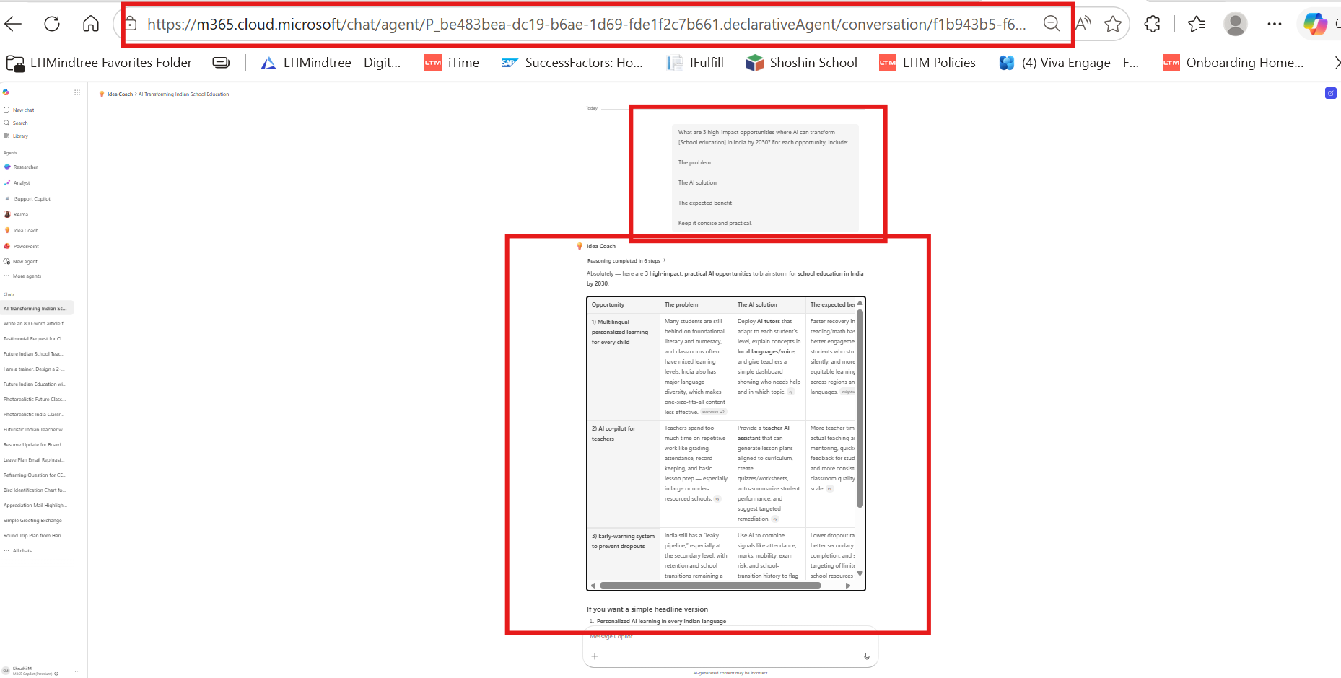
Prompt 2
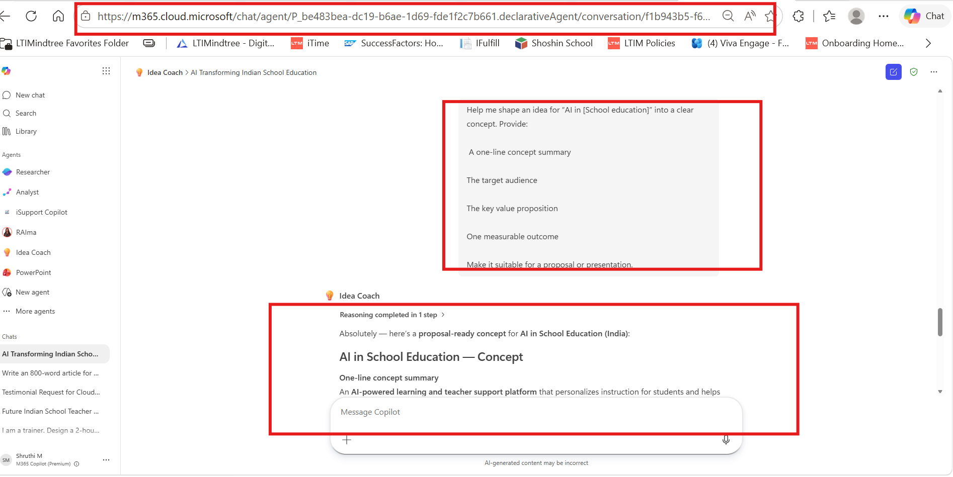
Prompt 3:
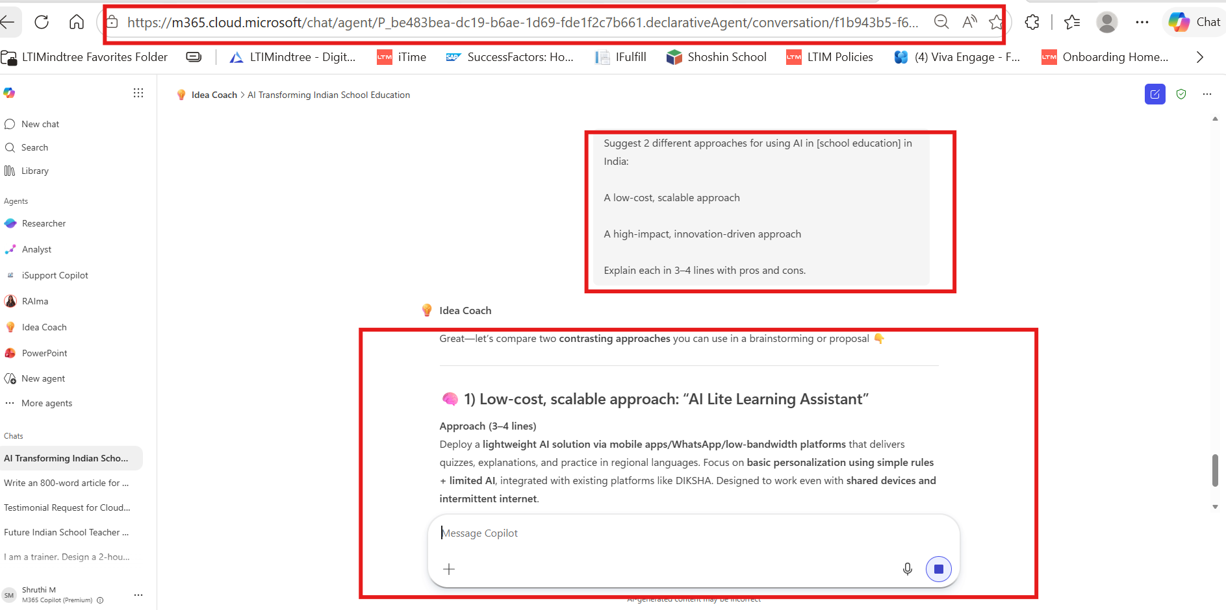
Prompt 4:
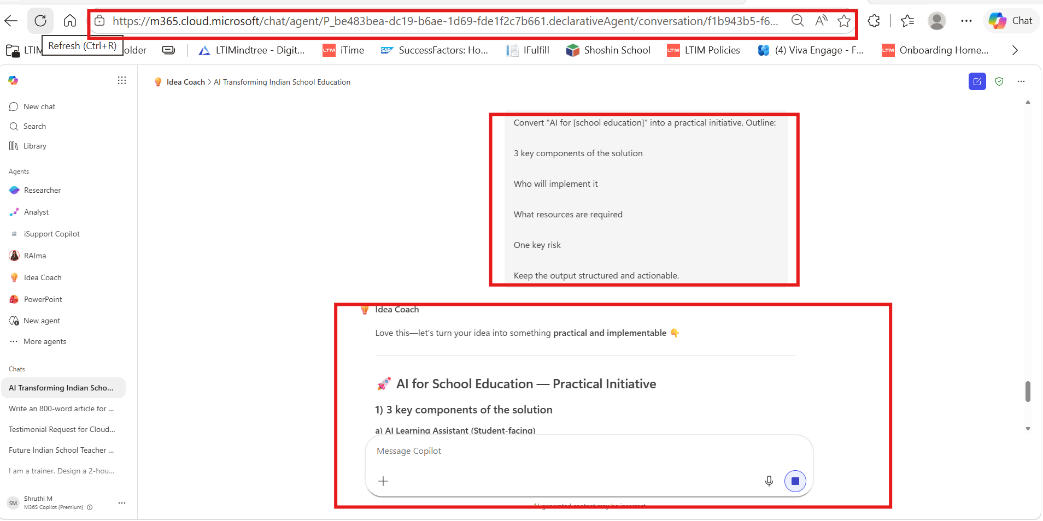
Prompt 5:
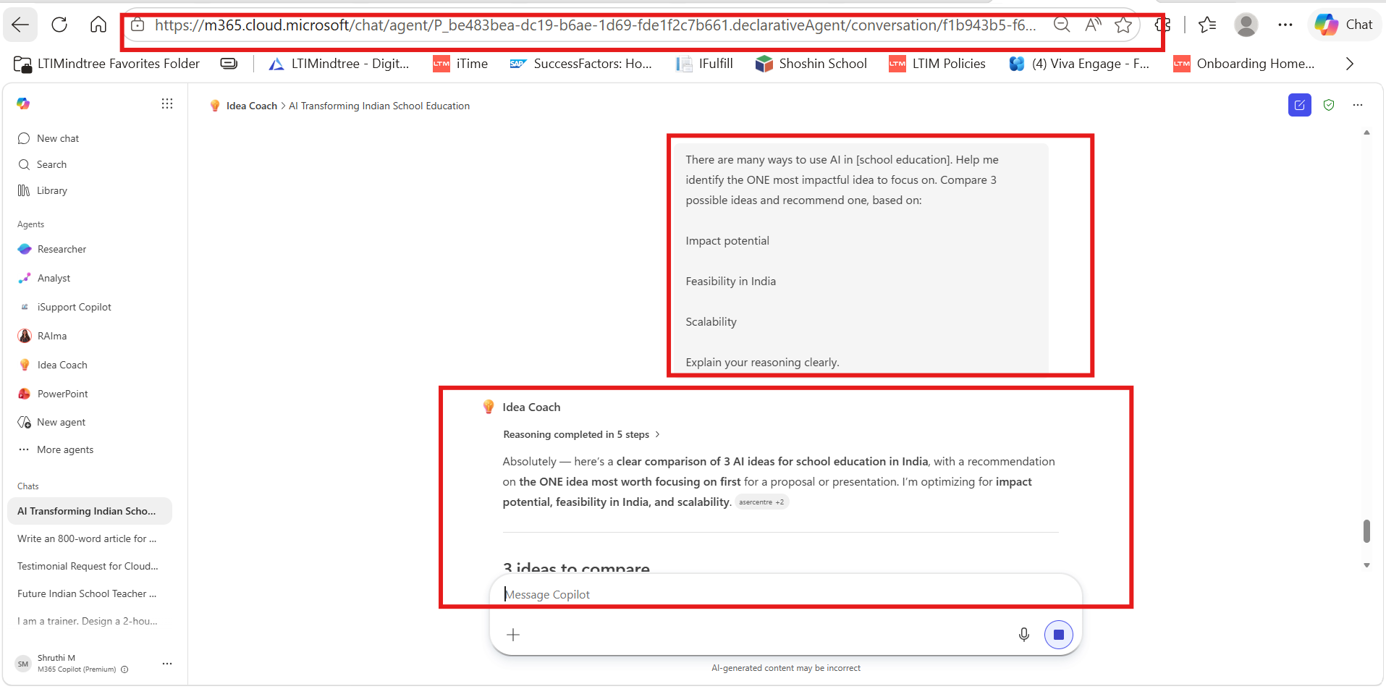
Prompt 6:
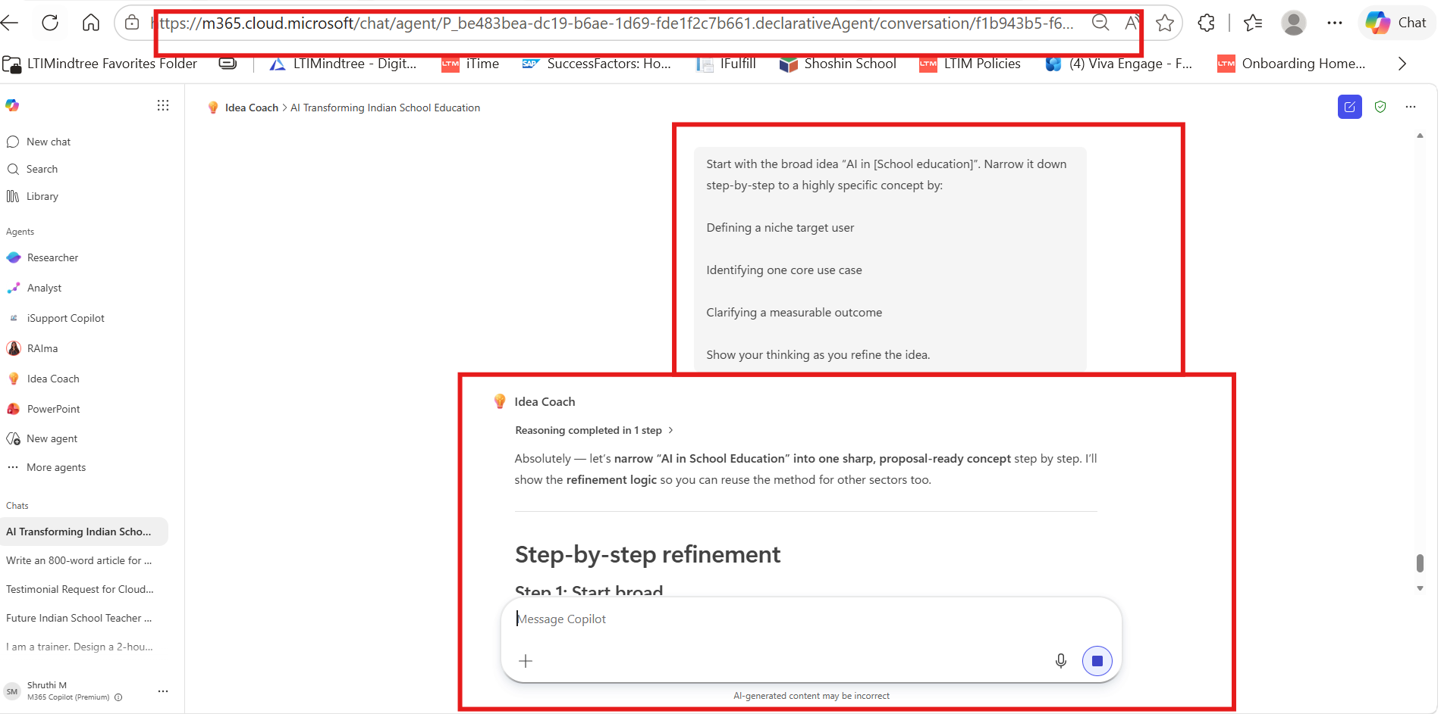

Outputs:
Prompt 1:
Idea Coach
Reasoning completed in 6 steps
Absolutely — here are 3 high-impact, practical AI opportunities to brainstorm for school education in India by 2030:
Opportunity | The problem | The AI solution | The expected benefit
1) Multilingual personalized learning for every child | Many students are still behind on foundational literacy and numeracy, and classrooms often have mixed learning levels. India also has major language diversity, which makes one-size-fits-all content less effective. [asercentre.org], [insightsonindia.com], [ey.com] | Deploy AI tutors that adapt to each student’s level, explain concepts in local languages/voice, and give teachers a simple dashboard showing who needs help and in which topic. [ey.com] | Faster recovery in reading/math basics, better engagement for students who struggle silently, and more equitable learning across regions and languages. [insightsonindia.com], [ey.com]
2) AI co-pilot for teachers | Teachers spend too much time on repetitive work like grading, attendance, record-keeping, and basic lesson prep — especially in large or under-resourced schools. [ey.com] | Provide a teacher AI assistant that can generate lesson plans aligned to curriculum, create quizzes/worksheets, auto-summarize student performance, and suggest targeted remediation. [ey.com] | More teacher time for actual teaching and mentoring, quicker feedback for students, and more consistent classroom quality at scale. [ey.com]
3) Early-warning system to prevent dropouts | India still has a “leaky pipeline,” especially at the secondary level, with retention and school transitions remaining a big challenge. [thehindu.com] | Use AI to combine signals like attendance, marks, mobility, exam risk, and school-transition history to flag students at risk of dropping out — then trigger interventions such as parent outreach, counselor support, transport/scholarship nudges, or bridge classes. [thehindu.com], [journalbharat.com] | Lower dropout rates, better secondary completion, and smarter targeting of limited school resources to the students who need support most. [thehindu.com], [journalbharat.com]
If you want a simple headline version
- Personalized AI learning in every Indian language
- AI co-pilot for every teacher
- AI early-warning system for dropout prevention
If you’d like, I can also turn this into a 1-slide executive summary, a pitch-ready speaking script, or 10 workshop prompts for brainstorming this topic with your team. Would you like me to tweak any of these suggestions?
How did I do? If this was useful, please consider using the thumbs up/down in Copilot.

Prompt 2:
Idea Coach
Reasoning completed in 1 step
Absolutely — here’s a proposal-ready concept for AI in School Education (India):
AI in School Education — Concept
One-line concept summary
An AI-powered learning and teacher support platform that personalizes instruction for students and helps teachers identify learning gaps early, especially in multilingual and mixed-ability classrooms in India. [asercentre.org], [ey.com], [thehindu.com]
Target audience
- Primary: K–12 students in government and affordable private schools
- Secondary: Teachers, school leaders, and education departments implementing learning improvement programs [ey.com], [thehindu.com]
Key value proposition
Improve foundational learning and retention by combining adaptive AI tutoring, regional-language support, and teacher dashboards that highlight which students need intervention—while reducing teacher time spent on repetitive academic tasks. [asercentre.org], [ey.com], [thehindu.com]
One measurable outcome
Increase the share of students achieving grade-level reading and math proficiency by 20% within one academic year in participating schools. This is highly relevant because foundational literacy and numeracy remain a major challenge in India’s school system. [asercentre.org], [insightsonindia.com], [thehindu.com]

Optional presentation version (shorter)
AI in School Education:
Use AI to deliver personalized, multilingual learning support for students and real-time insight tools for teachers, improving learning outcomes and reducing dropout risk in India’s classrooms. [ey.com], [thehindu.com]
If you want, I can also turn this into 2 sharper versions:
- a government/public-sector proposal version, or
- an innovation/pitch-deck version.
Would you like me to refine it toward government impact, CSR/social impact, or edtech business value?
How did I do? If this was useful, please consider using the thumbs up/down in Copilot.
Sources

Prompt 3:
Great—let’s compare two contrasting approaches you can use in a brainstorming or proposal 👇

🧠 1) Low-cost, scalable approach: “AI Lite Learning Assistant”
Approach (3–4 lines)
Deploy a lightweight AI solution via mobile apps/WhatsApp/low-bandwidth platforms that delivers quizzes, explanations, and practice in regional languages. Focus on basic personalization using simple rules + limited AI, integrated with existing platforms like DIKSHA. Designed to work even with shared devices and intermittent internet.
Pros
- Highly scalable across government schools and rural areas
- Low upfront cost; fast to deploy using existing infrastructure
- Easy adoption for teachers and students
Cons
- Limited depth of personalization and intelligence
- Less engaging vs. advanced interactive tools
- Depends on device access and basic digital literacy

🚀 2) High-impact, innovation-driven approach: “AI-Powered Smart Classroom Ecosystem”
Approach (3–4 lines)
Create a full AI-driven learning ecosystem with real-time adaptive learning, voice-based tutors in Indian languages, computer vision to track engagement, and predictive analytics to flag learning gaps and dropouts. Connected to teacher copilots + district dashboards for system-wide optimization.
Pros
- Deep personalization and significantly better learning outcomes
- Enables data-driven decisions at school and policy level
- Differentiated, future-ready education experience
Cons
- High cost (hardware, data infrastructure, training)
- Requires strong digital infrastructure and governance
- Adoption complexity for teachers and schools

💡 Quick framing for your presentation
- “Scale-first” model → Quick, inclusive reach
- “Intelligence-first” model → Maximum impact, slower rollout

If you’re turning this into a pitch, I can also help you combine both into a phased roadmap (Phase 1 → Phase 2) so it feels more realistic and fundable.
👉 Would you like me to design that hybrid roadmap next?
How did I do? 👍 / 👎

Prompt 4:
ove this—let’s turn your idea into something practical and implementable 👇

🚀 AI for School Education — Practical Initiative
1) 3 key components of the solution
a) AI Learning Assistant (Student-facing)
- Delivers personalized practice (math, reading) in regional languages via mobile/web
- Adapts difficulty based on student performance
- Works in low-bandwidth / shared-device environments
b) Teacher AI Co-pilot (Teacher-facing)
- Auto-generates lesson plans, quizzes, and remediation exercises
- Provides simple dashboards showing student learning gaps
- Reduces time spent on grading and admin tasks
c) Early Warning & Insights Engine (System-level)
- Tracks attendance, performance, and engagement trends
- Flags at-risk students for dropout or falling behind
- Provides actionable insights to schools/districts for intervention

2) Who will implement it
- Lead: State Education Departments / Ministry of Education
- Execution partners:
  - EdTech companies (AI platform development)
  - NGOs (on-ground training and adoption)
  - School administrators and teachers (daily usage)
- Support: Digital public platforms (e.g., integration with existing systems)

3) What resources are required
- Technology: AI platform, cloud infrastructure, multilingual datasets
- Access layer: Smartphones/tablets or shared digital devices in schools
- Connectivity: Basic internet (plus offline functionality for rural areas)
- Human enablement: Teacher training programs + ongoing support
- Funding: Government + CSR/PPP models for scale

4) One key risk
Low adoption by teachers due to change resistance or lack of training
- If teachers find the system complex or misaligned with curriculum, usage drops → impact fails

💡 Quick pitch version (if you need it)
“Deploy a scalable AI-powered learning and teaching support system that improves student outcomes, enables data-driven interventions, and reduces teacher workload—while being designed for India’s multilingual, low-resource classrooms.”

👉 Want to refine this further into a pilot plan (e.g., 100 schools rollout roadmap) or tailor it for a government vs CSR proposal?

Prompt 5:
Reasoning completed in 5 steps
Absolutely — here’s a clear comparison of 3 AI ideas for school education in India, with a recommendation on the ONE idea most worth focusing on first for a proposal or presentation. I’m optimizing for impact potential, feasibility in India, and scalability. [asercentre.org], [udiseplus.gov.in], [dashboard....lus.gov.in]

3 ideas to compare
Idea 1: Multilingual AI Tutor for foundational learning
What it is:
An AI learning assistant that gives students personalized practice in reading and math, explains concepts in regional languages, and adapts to each child’s level. This directly addresses India’s persistent foundational learning gaps and classroom diversity. [insightsonindia.com], [ey.com], [insightsonindia.com]
Why it matters:
ASER 2024 still shows large basic learning gaps—many children in early grades are below expected reading and arithmetic levels—so this idea attacks the biggest system bottleneck first. [insightsonindia.com], [thehindu.com]
Assessment:
- Impact potential: Very high — directly improves student learning outcomes, which is the core education problem. [insightsonindia.com], [thehindu.com]
- Feasibility in India: Medium-High — smartphone access among older students is meaningful, and AI-enabled multilingual content is already becoming more practical through Indian language ecosystems and public platforms. [insightsonindia.com], [ey.com], [digit.in]
- Scalability: High — once built, it can scale across states through existing digital rails and low-cost mobile delivery, though connectivity still varies. [digit.in], [insightsonindia.com], [dashboard....lus.gov.in]

Idea 2: AI Co-pilot for teachers
What it is:
An AI assistant for teachers that helps generate lesson plans, quizzes, remedial exercises, grading support, and simple class insights. It reduces repetitive work and helps teachers focus on actual teaching. [ey.com], [insightsonindia.com]
Why it matters:
India’s school system is massive, teachers face uneven workloads, and better planning plus faster remediation can improve classroom quality without replacing teachers. [ey.com], [udiseplus.gov.in]
Assessment:
- Impact potential: High — strong indirect impact because better teachers improve many classes, but gains may be less visible than student-facing learning tools. [ey.com], [insightsonindia.com]
- Feasibility in India: High — easier to deploy than advanced student AI because it requires fewer devices per learner and can be piloted through teacher workflows first. [ey.com], [insightsonindia.com]
- Scalability: High — can be rolled out through teacher training and platforms such as DIKSHA-like ecosystems, especially where device availability per student is low. [educationf...nindia.com], [ey.com]

Idea 3: AI early-warning system for dropout and low attendance
What it is:
An AI system that uses attendance, assessment, transition, and engagement data to identify students at risk of dropping out, so schools can intervene early. [thehindu.com], [dashboard....lus.gov.in]
Why it matters:
India still faces a “leaky pipeline,” especially at secondary level, and retention remains a major challenge despite improved access. [thehindu.com], [dashboard....lus.gov.in]
Assessment:
- Impact potential: High — very valuable for retention, especially in secondary school. [thehindu.com], [dashboard....lus.gov.in]
- Feasibility in India: Medium — depends on reliable student-level data, district coordination, and intervention capacity after the algorithm raises a flag. [udiseplus.gov.in], [thehindu.com]
- Scalability: Medium-High — national data systems like UDISE+ improve the case, but impact depends on actual response systems on the ground, not just analytics. [udiseplus.gov.in], [thehindu.com]

Quick comparison
Idea | Impact potential | Feasibility in India | Scalability | Verdict
1. Multilingual AI Tutor | Very high — directly improves learning outcomes | Medium-High — needs device + language + content readiness | High | Best overall bet
2. Teacher AI Co-pilot | High | High | High | Best “easy-to-start” option
3. Dropout Early-Warning | High | Medium | Medium-High | Strong policy/support tool
The core trade-off is this: Teacher co-pilots are easiest to deploy first, but multilingual AI tutors create the strongest direct learning impact if executed well. [ey.com], [insightsonindia.com], [insightsonindia.com]

Recommended focus: Multilingual AI Tutor for foundational learning
Why this is the best single idea
1) It targets the biggest problem first
India’s most urgent school-education challenge is still foundational literacy and numeracy, and ASER 2024 shows that large proportions of students remain below grade level. If students do not master basics early, nearly every later reform underperforms. [insightsonindia.com], [thehindu.com]
2) It has the clearest outcome story
This idea is easier to defend in a proposal because the result is measurable: improve reading and math proficiency. That is more tangible than “teacher productivity” alone and more immediate than a retention model that depends on external interventions. [insightsonindia.com], [thehindu.com]
3) It fits India’s diversity better than one-size-fits-all edtech
India’s classrooms are multilingual and mixed-ability, and AI is particularly strong when used for adaptive learning + local language support, which traditional static content struggles to do well. [ey.com], [insightsonindia.com], [digit.in]
4) It can still be rolled out pragmatically
A smart version of this idea does not need a futuristic smart classroom everywhere. It can start as a mobile-first, low-bandwidth, multilingual foundational learning assistant in selected grades and geographies, then expand. That makes it more scalable than it first appears. [insightsonindia.com], [dashboard....lus.gov.in], [digit.in]

Best proposal framing
Focus idea:
“AI-powered multilingual foundational learning tutor for Grades 1–5” that identifies each student’s learning level, delivers adaptive reading/math practice in local languages, and gives teachers simple remediation insights. [insightsonindia.com], [ey.com], [insightsonindia.com]
Why this framing works:
It combines student impact, teacher support, and India-specific practicality in one concept rather than trying to solve everything at once. [ey.com], [digit.in]

One-line recommendation for your slide
Recommendation: Prioritize a multilingual AI tutor for foundational literacy and numeracy, because it offers the strongest combination of high impact, India relevance, and long-term scalability by addressing the system’s biggest learning gap first. [insightsonindia.com], [thehindu.com], [insightsonindia.com]
If you want, I can next turn this into either:
- a 1-slide executive recommendation, or
- a proposal-ready concept note with objective, implementation model, and KPI.
Would you like me to shape it into one of those, or make any changes to the recommendation?
How did I do? If this helped, please consider using the thumbs up/down in Copilot.
Sources


Prompt 6:
Idea Coach
Reasoning completed in 1 step
Absolutely — let’s narrow “AI in School Education” into one sharp, proposal-ready concept step by step. I’ll show the refinement logic so you can reuse the method for other sectors too.

Step-by-step refinement
Step 1: Start broad
Broad idea
AI in School Education
Why this is too broad
It could mean many things: tutoring, teacher support, assessments, school administration, dropout prediction, career guidance, special education, etc.
To make it actionable, we need to narrow it by:
- Who exactly is it for?
- What one problem are we solving?
- What measurable change will prove it works?

Step 2: Define a niche target user
Possible target users
- All K–12 students
- Teachers in government schools
- School administrators
- Parents
- Students at risk of dropping out
- Early-grade students struggling with basics
Refinement logic
The highest-impact need in India is still foundational literacy and numeracy, especially in early grades. ASER 2024 shows large learning gaps remain in reading and arithmetic, even after recovery from pandemic-era losses. [impressivetimes.com], [educationf...nindia.com]
Narrowed target user
Students in Grades 1–5 in government schools who are below grade level in reading and math
Why this niche works
- It focuses on the biggest learning bottleneck first. [impressivetimes.com], [educationf...nindia.com]
- It is easier to design for one segment than for “all students.”
- Early intervention creates the strongest long-term impact.

Step 3: Identify one core use case
Possible use cases for this target group
- AI tutor for personalized practice
- AI assessment engine
- Teacher co-pilot for remediation
- Reading fluency coach
- Attendance/dropout risk alerts
Refinement logic
If the target user is early-grade students below grade level, the most direct use case is not school administration or advanced smart classrooms — it is personalized foundational learning support. AI is particularly useful here because it can adapt difficulty, repeat explanations, and support multiple Indian languages. [thetuitioncenter.com]
Narrowed core use case
A multilingual AI tutor that gives each child personalized daily practice in reading and basic math
Even more specific
- Works on low-cost mobile/tablet devices
- Supports regional languages + voice prompts
- Gives short 10–15 minute adaptive practice sessions
- Flags weak concepts for the teacher
Why this is the best core use case
It directly addresses:
- mixed learning levels in one classroom
- language diversity
- limited one-to-one teacher time
- the need for measurable academic improvement [thetuitioncenter.com], [impressivetimes.com], [educationf...nindia.com]

Step 4: Clarify the measurable outcome
Possible outcomes
- More usage of digital tools
- Better teacher productivity
- Better attendance
- Improved reading and math proficiency
- Reduced dropout risk
Refinement logic
The strongest proof point is a student learning outcome, not just adoption or engagement. For this concept, the clearest KPI is improvement in grade-level reading and arithmetic proficiency.
Measurable outcome
Increase the percentage of Grade 3–5 students achieving grade-level reading and basic arithmetic proficiency by 20% within one academic year
Why this metric works
- Easy to explain in a proposal
- Aligned with India’s foundational learning agenda
- Can be measured through baseline vs endline assessments [impressivetimes.com], [thehindu.com]

Final refined concept
Highly specific concept
A multilingual AI foundational-learning tutor for below-grade-level students in Grades 1–5 in Indian government schools, delivering daily personalized reading and math practice and helping teachers track improvement.

The refinement path at a glance
Stage | Decision | Why it narrows well
Broad idea | AI in School Education | Too wide to implement clearly
Target user | Grade 1–5 government school students below grade level | Focuses on the biggest unmet need
Core use case | Multilingual personalized AI tutor for reading + math | Directly solves learning gaps
Measurable outcome | +20% improvement in grade-level proficiency in 1 academic year | Makes success easy to prove

Proposal-ready version
Concept title
AI Tutor for Foundational Learning in Government Schools
One-line summary
A low-cost, multilingual AI tutor that helps early-grade students in government schools build reading and numeracy skills through personalized daily practice.
Target user
Students in Grades 1–5 who are performing below grade level in reading and math.
Core use case
Deliver adaptive, regional-language learning support for foundational literacy and numeracy, while giving teachers a simple dashboard for targeted remediation.
Measurable outcome
Improve grade-level reading and arithmetic proficiency by 20% within one academic year in participating schools.

Why this is the strongest focus
If you try to solve “all of school education,” the idea becomes vague.
If you focus on:
- one user → early-grade struggling students
- one use case → personalized foundational learning
- one metric → proficiency improvement
…you get a concept that is clear, fundable, and pilot-ready.

If you want, I can take this one step further and turn it into either:
- a 1-slide pitch summary, or
- a problem → solution → impact concept note for a proposal.
Would you like me to tighten this into a more government-style, CSR-style, or startup-style concept?
How did I do? If this was useful, please consider using the thumbs up/down in Copilot.
Sources


